## What is RSS?

RSS (Rich Site Summary) is **a format for delivering regularly changing web content**. Many news-related sites, weblogs and other online publishers syndicate their content as an **RSS Feed** to whoever wants it.

## Why RSS? Benefits and Reasons for using RSS

RSS solves a problem for people who regularly use the web. It allows you to **easily stay informed** by retrieving the latest content from the sites you are interested in. You **save time** by not needing to visit each site individually. You **ensure your privacy**, by not needing to join each site's email newsletter.

## What do I need to do to read an RSS Feed? RSS Feed Readers and News Aggregators

Feed Reader or News Aggregator software allow you to grab the RSS feeds from various sites and display them for you to read and use.

A [variety of RSS Readers](http://blogspace.com/rss/readers) are available for different platforms. Some popular feed readers include [Amphetadesk](http://www.disobey.com/amphetadesk/) (Windows, Linux, Mac), [FeedReader](http://www.feedreader.com/) (Windows), and [NewsGator](http://www.newsgator.com/) (Windows - integrates with Outlook). There are also a number of web-based feed readers available. Personally, the easiest is Microsoft Outlook if you are using this for your email anyway. Guidance for using Outlook as an RSS reader can be found below.

Once you have your Feed Reader, it is a matter of finding sites that syndicate content and adding their RSS feed to the list of feeds your Feed Reader checks. The ChangingEmployment web-site displays a small icon with the linked text “subscribe to our news feed” to the XML code to let you know a feed is available:



#### Grab the URL of this page and copy this into the reader.

#### <http://www.changingemployment.eu/DesktopModules/DnnForge%20-%20NewsArticles/Rss.aspx?TabID=3428&ModuleID=6347&MaxCount=25>

#### 

#### *Source:* [*www.WhatIsRSS.com*](http://www.whatisrss.com/)

**Using Outlook 2010 as an RSS reader**

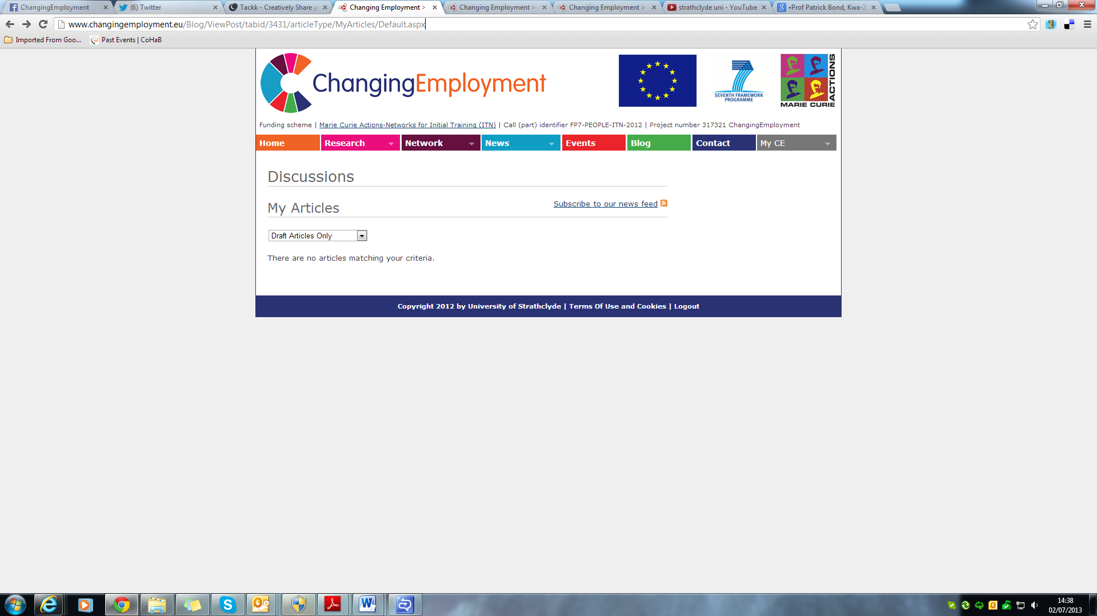You can create a feed in MS Outlook which tells you when a new items has been posted. Here are the instructions for setting this up in MS Outlook 2010:

Youtube video instructions:

[http://www.youtube.com/watch?feature=player_embedded&v=xRc04tXB3X0#](http://www.youtube.com/watch?feature=player_embedded&v=xRc04tXB3X0)!

Click on the File menu –> Info and click on the Account Settings

[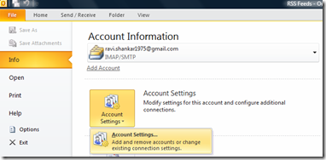](http://blogmines.com/blog/images/upload/2010/06/image31.png)

Navigate to RSS feeds tab and click on New link

[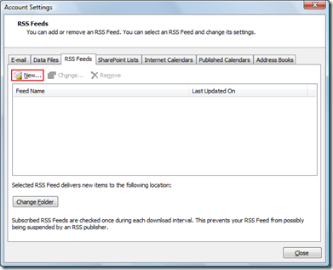](http://blogmines.com/blog/images/upload/2010/06/image32.png)

**Enter the RSS feed** of a blog or a website. In this example I am going to enter this tech blog RSS feed.

[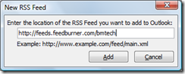](http://blogmines.com/blog/images/upload/2010/06/image33.png)

Click on the Add button to add the RSS feed. The following RSS Feed Options dialog box would be displayed and if you want to change **the delivery location** of the RSS feed then click on the Change Folder button and specify the desired location. Click Ok to confirm the changes.

[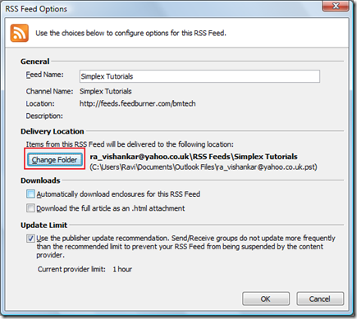](http://blogmines.com/blog/images/upload/2010/06/image34.png)

Navigate to RSS Feed delivery location, this will display the RSS feeds

[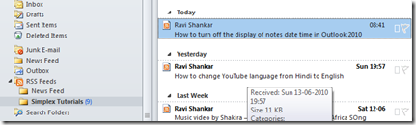](http://blogmines.com/blog/images/upload/2010/06/image35.png)